|  |
| --- |
| Version v4 |
| Standard Operating Procedure |
| 537DSSD - DRUG INTERACTION |
|  |
| Authored By: EMT OPERATIONS & TRIADS LAB |
|  |

01-August-16

**Fourth Draft**

E-Merge tech Global Services Pvt Ltd

Chennai, India

[www.e-mergeglobal.com](http://www.e-mergeglobal.com)

US Toll Free: 1-888-247-1618

**The CEO is a Member of PIUG, IEEE, AUTM & LES**

Contents

1. Purpose 2

2. Scope 2

3. Source 2

4. Definitions 2

5. Work Flow 4

6. General Instructions 4

# 1. Purpose

The purpose of this document is to provide instructions for the manual annotation using DBMI-Annotator tool. The purpose of the project is to extract Pharmacokinetic data from the given set of publications. The following major Pharmacokinetic information should be extracted:

* **Claim**
* **Object drug, dose, form, and schedule**
* **Precipitant drug, dose, form, and schedule**
* **AUC Ratio**
* **Cmax Ratio**
* **Clearance Ratio**
* **Half-life (T1/2) Ratio**
* **[Number of] Participants**
* **Evidence Relationship**
* **Randomization**

# 2. Scope

The scope of this pharmacokinetic data curation project is to identify the drug interaction data and its effects. There will be two types of drugs discussed in most of the cases; these are Object Drug and Precipitant Drug.

# 3. Source

* List of publications provided to E-Merge tech by University of Pittsburgh.

# Definitions

* **Claim:** An assertion about a relationship between entities in the domain of discourse (in this case drug-drug interactions) that is supported or refuted by evidence. The word claim in this context is a generally synonymous with assertion though the latter is used more often to describe a claim’s logical formalization.
* **Object Drug**: The drug whose action is altered by the interaction
* **Precipitant Drug**: The drug that causes the altered action of the altered drug
* **AUC**: (Definite Integral) is the plot of concentration of drug in blood plasma against time. Usually it is calculated from the start of the administration of the drug till the drug concentration becomes negligible
* **AUC Ratio**: The ratio of the AUC (as fold or percent increase or decrease) of the object drug in the presence of the purported precipitant drug
* **Cmax:**It is defined as maximum (or peak) serum concentration that a drug achieves in a specified compartment or test area of the body after the drug has been administrated and prior to the administration of a second dose
* **Cmax Ratio**: The ratio of the Cmax (as fold or percent increase or decrease) of the object drug in the presence of the purported precipitant drug
* **T1/2 :** (Half life) The duration of action of the drug is known as Half-life. This is the time period required by the drug to reach it concentration or amount to half
* **T1/2 Ratio**: The ratio of the T1/2 (as fold or percent increase or decrease) of the object drug in the presence of the purported precipitant drug
* **Clearance:** The rate at which a drug is removed from the plasma is known as clearance
* **Clearance Ratio**: The ratio of the Clearance (as fold or percent increase or decrease) of the object drug in the presence of the purported precipitant drug
* **Number of participants:** The number of participants entered into a clinical trial. (Note: this is different than number of participants who complete, which is participants - dropouts)
* **Evidence Relationship:** If the evidence supports or refuses the claim.
* **Randomization:** ‘Yes’ if the study randomized participants to exposure or order of exposure

# Work Flow

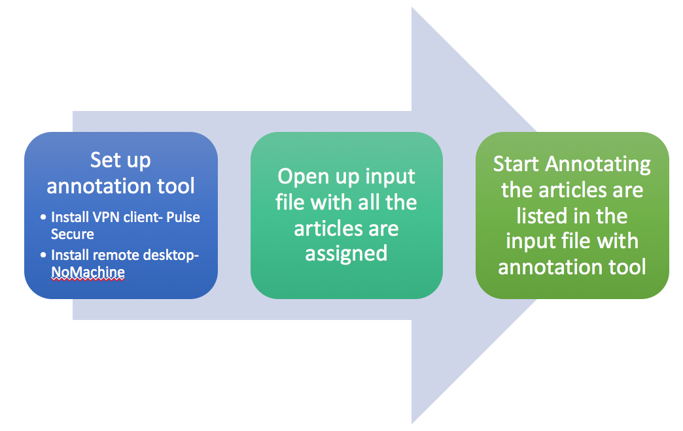

# General Instructions

E-Merge tech will be provided with an input spreadsheet and access to an online annotation interface:

1. **Set Up Annotation Tool:** The web interface used for annotation
2. Install VPN client and remote into our network.

* Install VPN client (Pulse Secure) on your computer
* Open up Pulse Secure and add a connection like below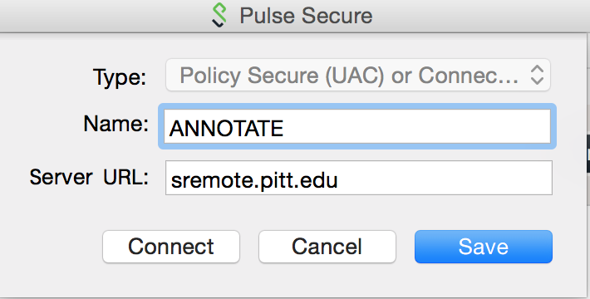
* Click Connect to continue and select Network Connect to continue 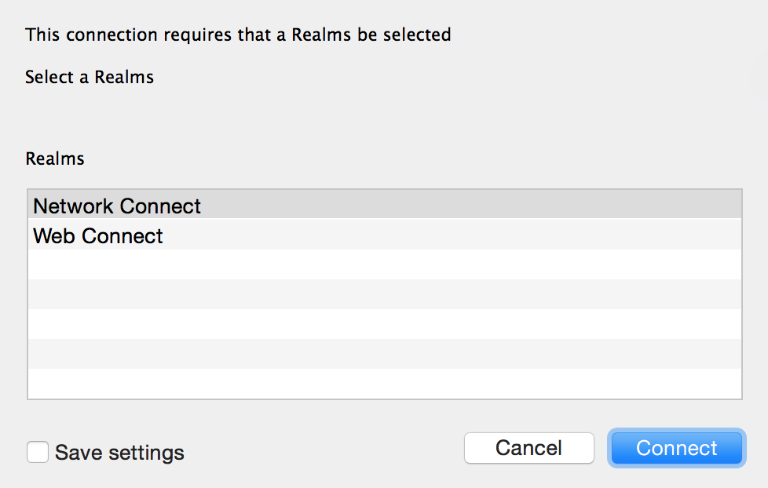
* Type in the username “ANNOTAT1” and password to connect

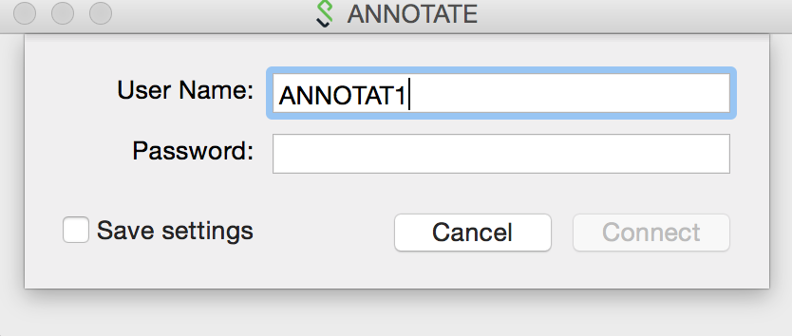

* Select VPN role “Firewall-DBMI-annotator-SecureConnect” and click connect

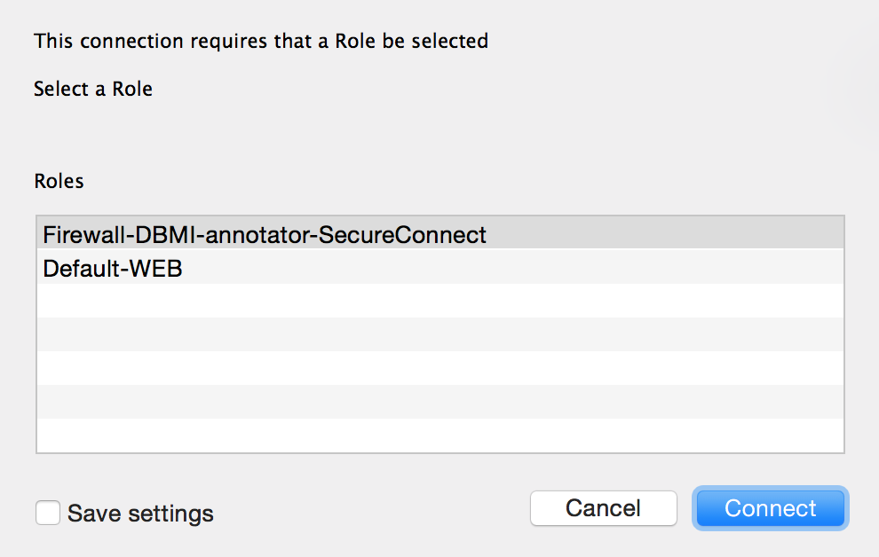

*Note: We’ll have 5 accounts for you later to do annotations. The current one is just for testing.*

1. Install remote desktop

* Download NoMachine as the remote desktop tool from [https://www.nomachine.com](https://www.nomachine.com/)
* Open up NoMachine to create a new connection after installation. Here are the connection information: **Protocol: NX** 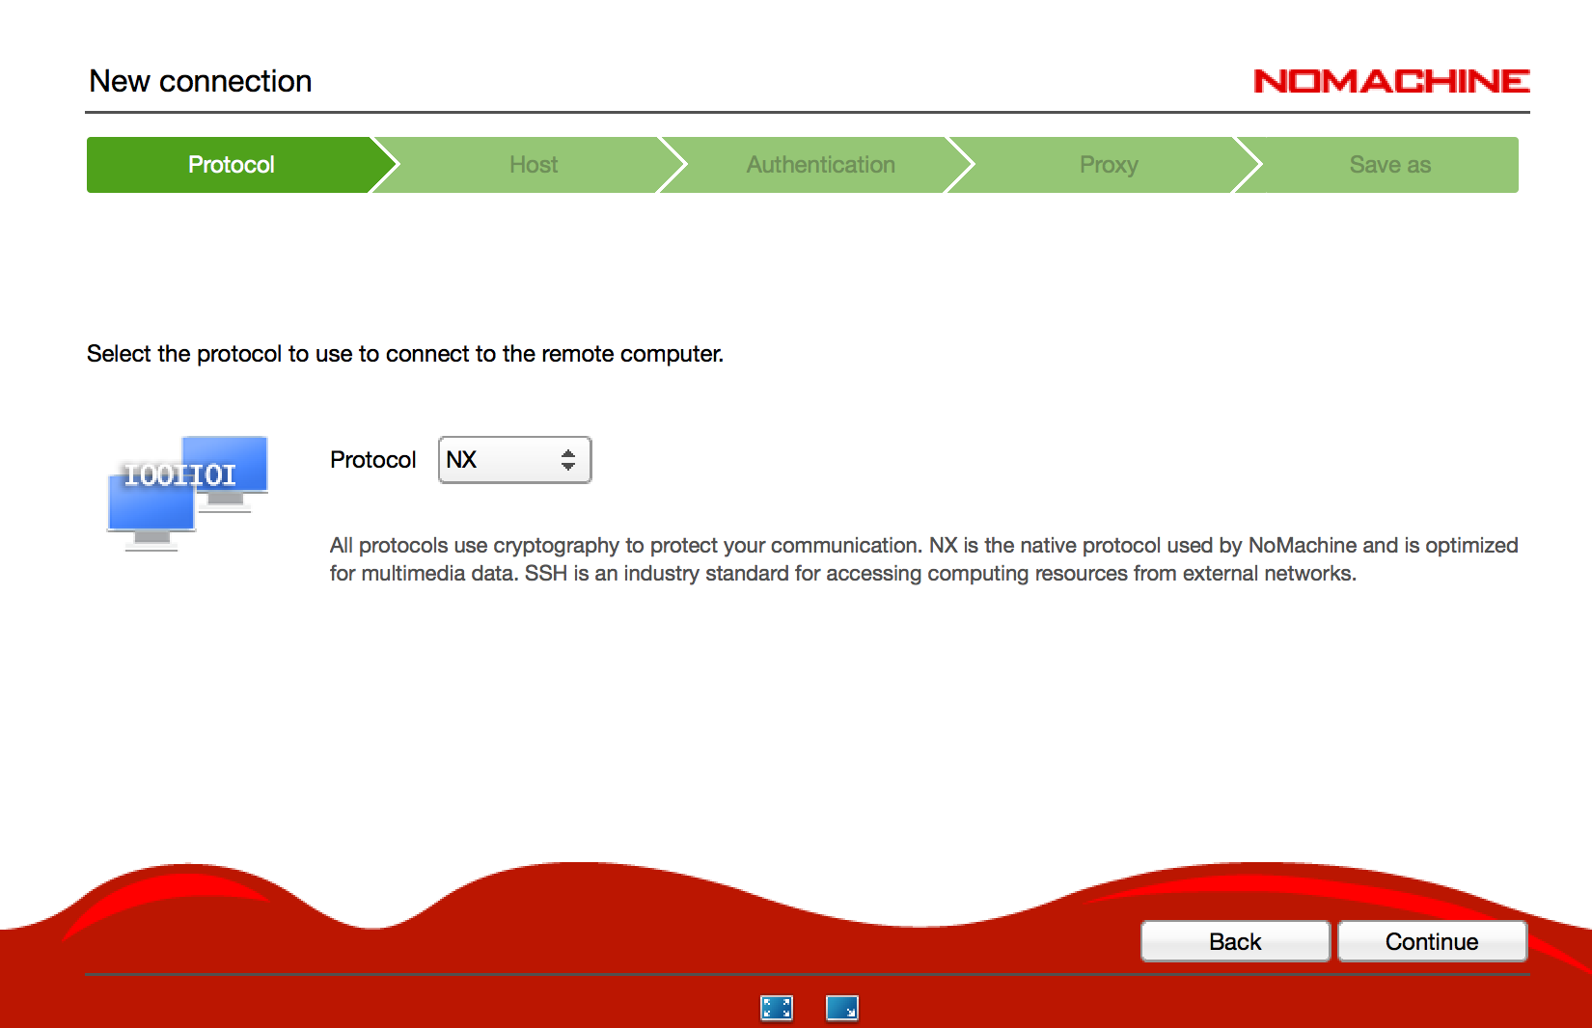

**Host IP: 10.247.2.23, Port: 4000**

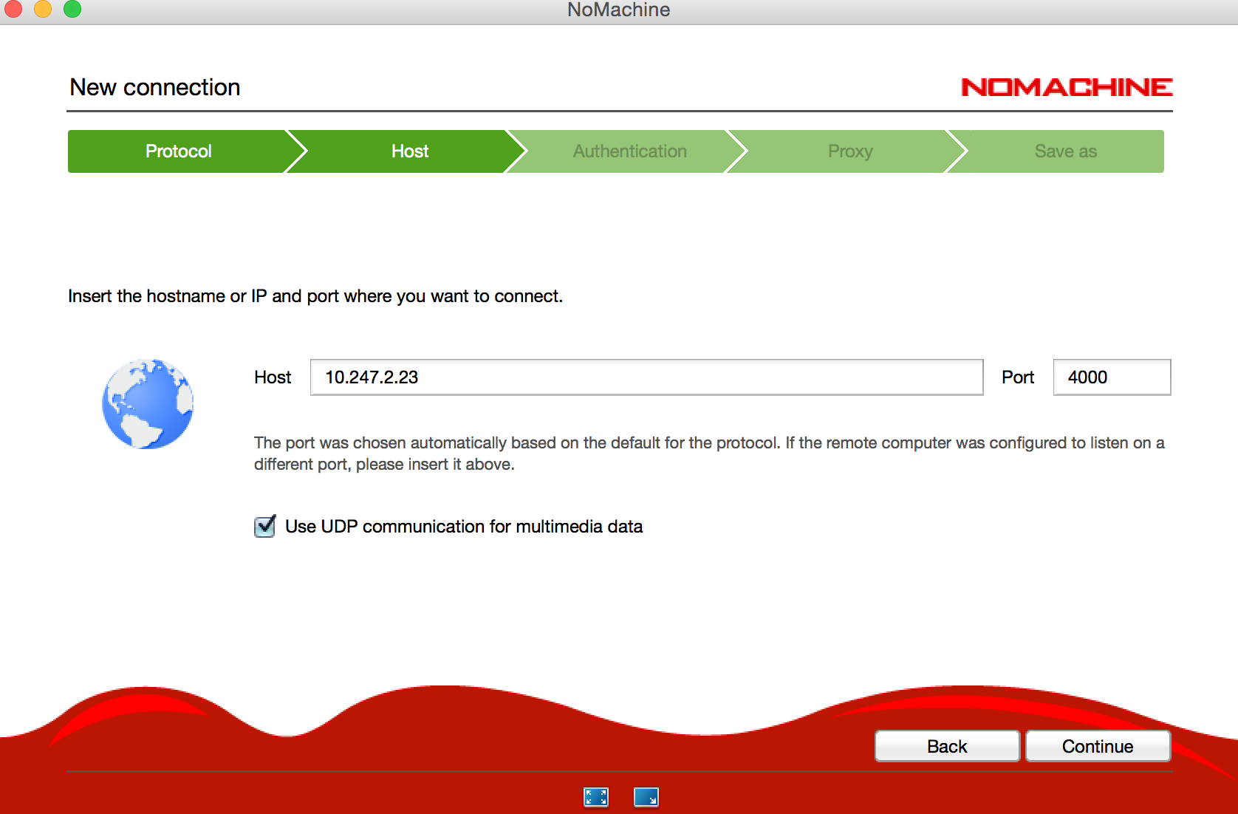

**Authentication method: password**

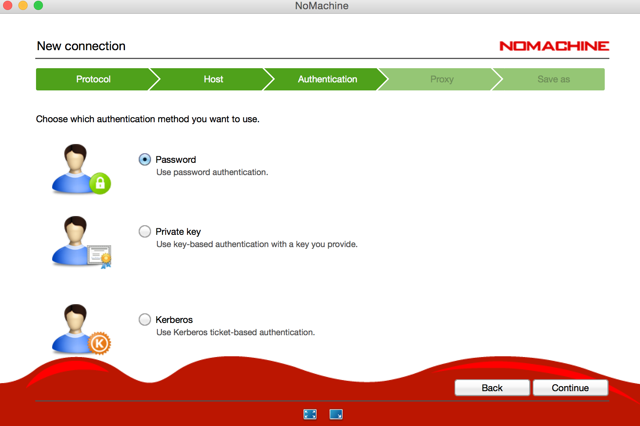

**Proxy: Don’t use a proxy**

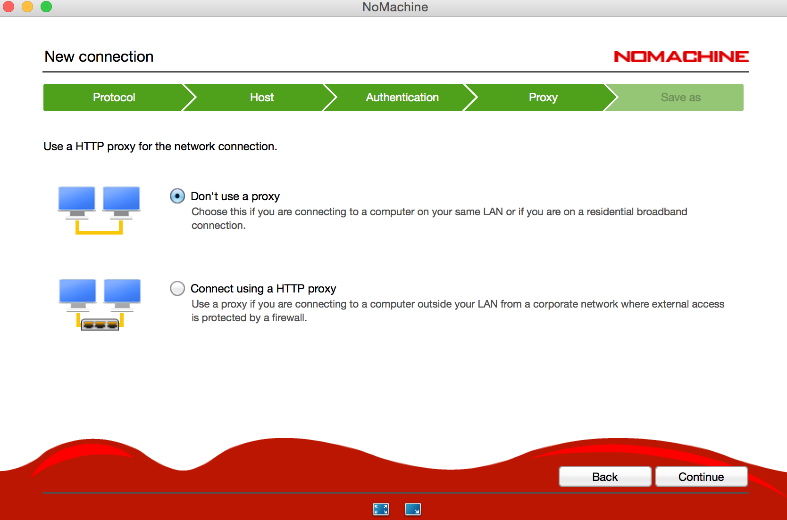

* After you click continue, please click yes if there is any warning box pops up. Then, type in username “ annotat1” and password to log in VLAN server

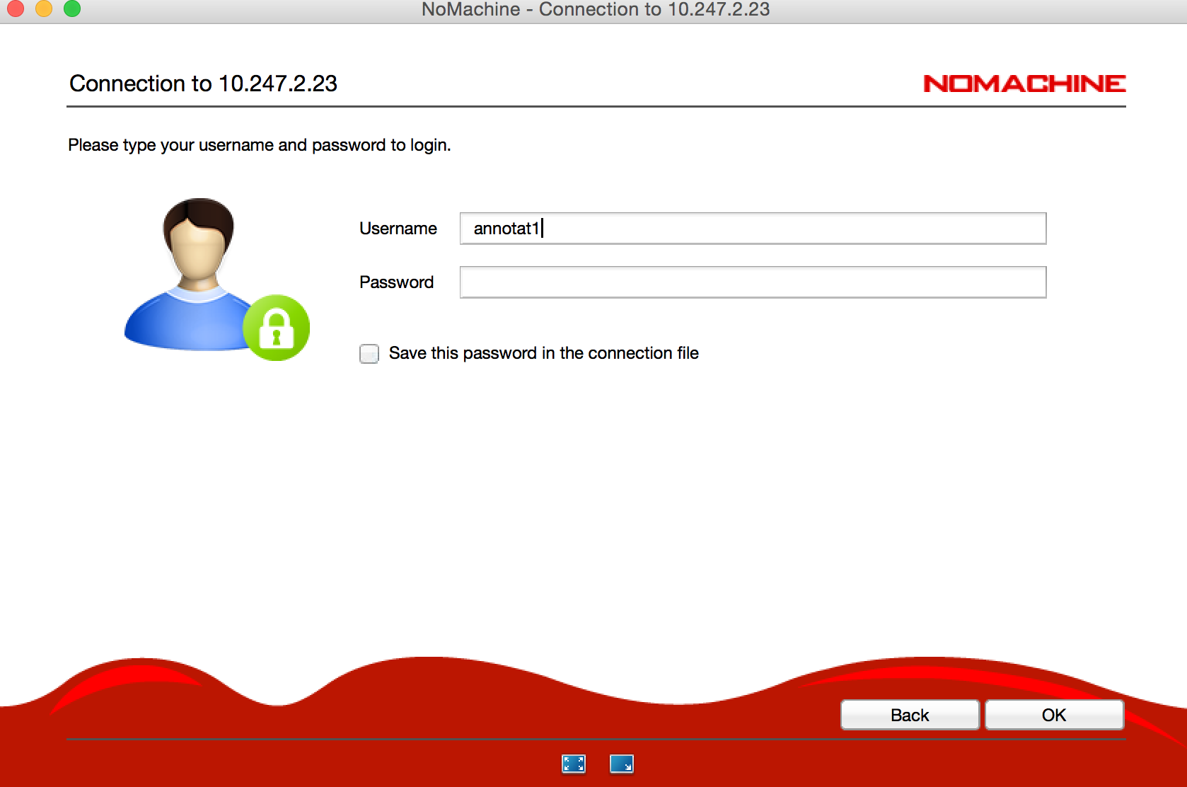

* A screen will be available after you log in to the server.

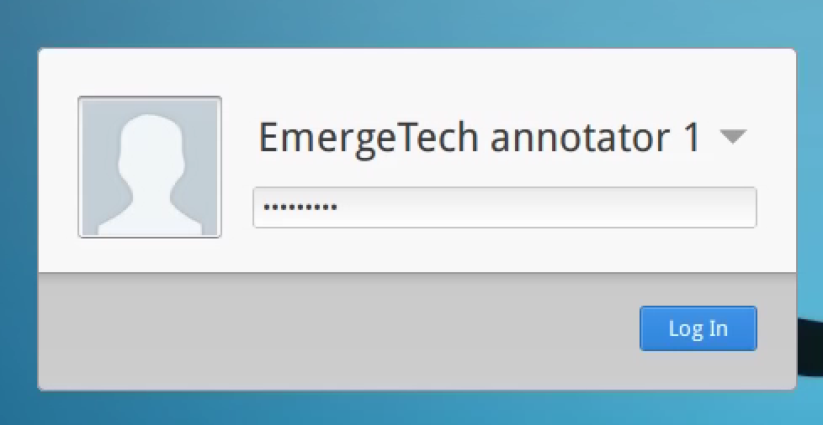

* Please click the icon “firefox” to open up firefox web browser.



* Then you can type in the url <http://localhost/dbmiannotator> to access our annotator tool. If you see an interface like this on the screen, congratulation, you access the annotation tool successfully.

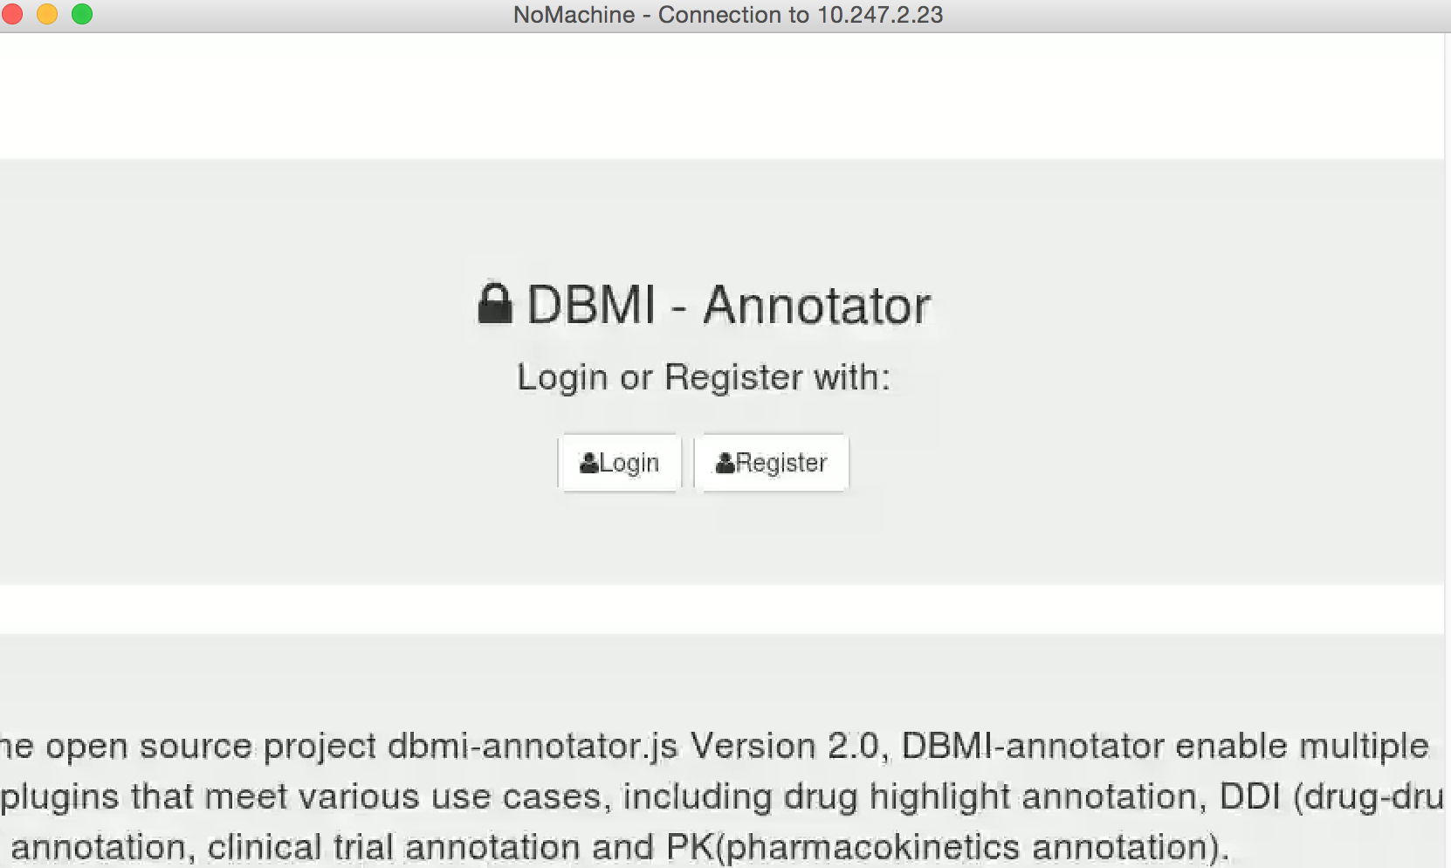

1. After you see the login page, click login button and type in the username “test@gmail.com” and password to start the work.
2. The next step is to open up the input file, find the articles are assigned and annotate their information using the annotation tool.
3. **Open Up Input File:** The file lists all the articles and information are needed for doing annotations. To open up the input file, please type this url <http://10.247.2.23:3000/mp-testing-case/PMC-Articles.html> into a new tab on the same firefox browser and follow the process on next page.

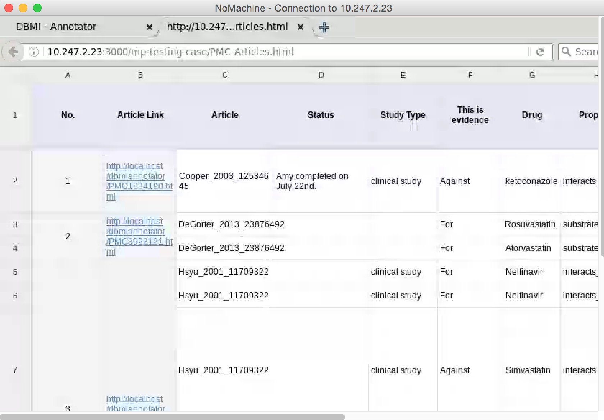

Process

(1) Check input column *Meets Inclusion Criteria* of the Input spreadsheet. Annotate **only** if the inclusion criteria said Yes.

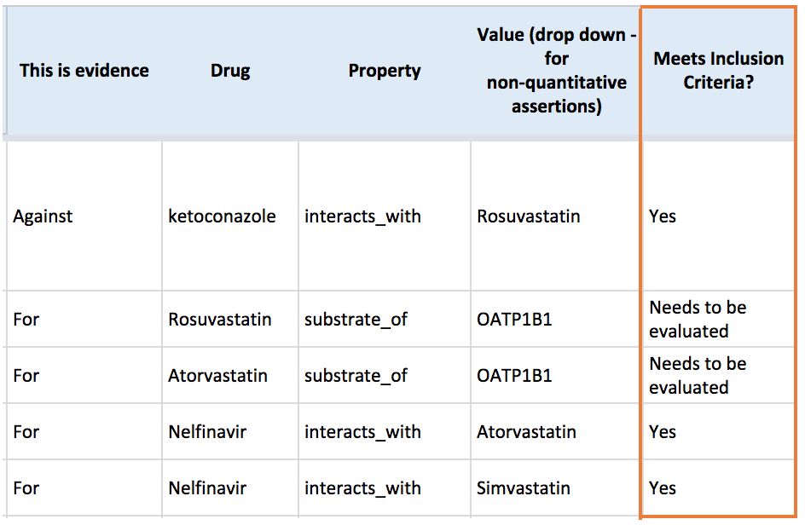

(2) In the annotation interface, find the article needs to be annotated and open its article link listed in input column *Article Link*

For example: Article (Cooper_2003_12534645),

Article Link(http://localhost/dbmiannotator/PMC1884190.html)

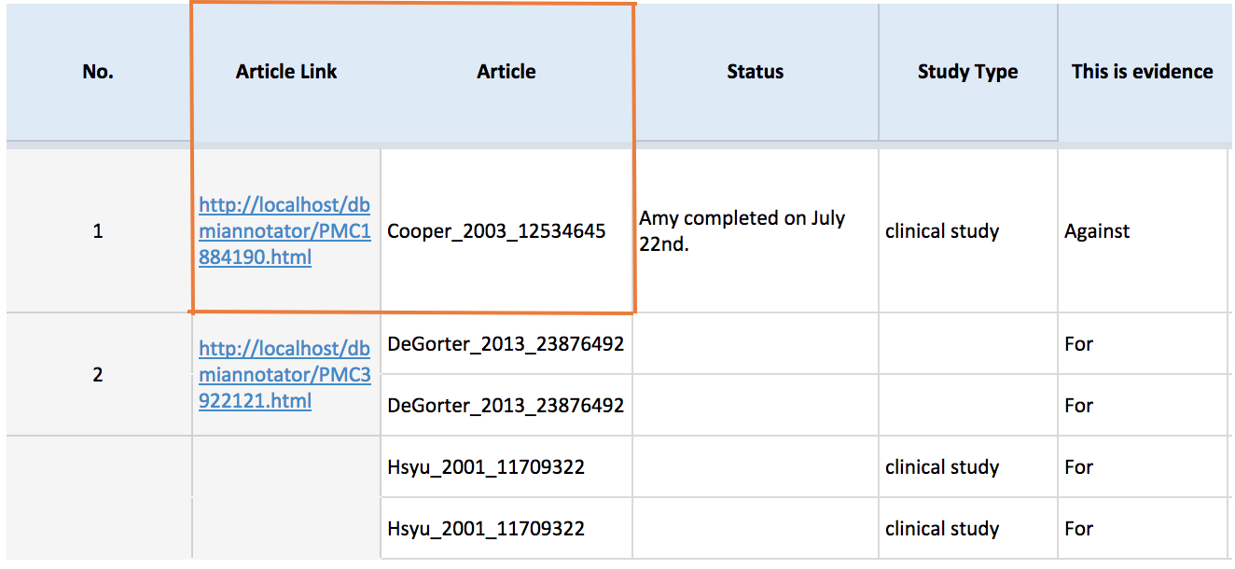

***Note: the table below explains all the information is needed by annotation tool and the columns in the input file.***

|  |  |
| --- | --- |
| Information is needed by annotation tool | Information location in input file |
| Whether to annotate | *Column:* Meets inclusion criteria? |
| Article to be annotated | *Column: Article* |
| Main Claim | *Column: The sentence(s) that state the main assertion* |
| Drug1 | *Column: Drug* |
| Relationship | *Column: Property* |
| Method type | *Clinical Trial* |
| Drug2/inhibitor | *Column:**Value (drop down - for non-quantitative assertions* |
| Participants | *Column:* *The sentence(s), table(s), and/or figure(s) that specify the methods* and *Column: The sentence(s), table(s), and/or figure(s) that specify the results* |
| AUC Ratio, Cmax Ratio, Clearance Ratio, and/or Half-life (T1/2) Ratio | *Column: The sentence(s), table(s), and/or figure(s) that specify the results* |
| Ev_relationship (evidence relationship) | *Column: This is evidence. If it’s an “against”, then selects “refuse”, otherwise selects “support”.* |

(3) In the annotation interface, find the article needs to be annotated and open its article link listed in input column *Article Link*

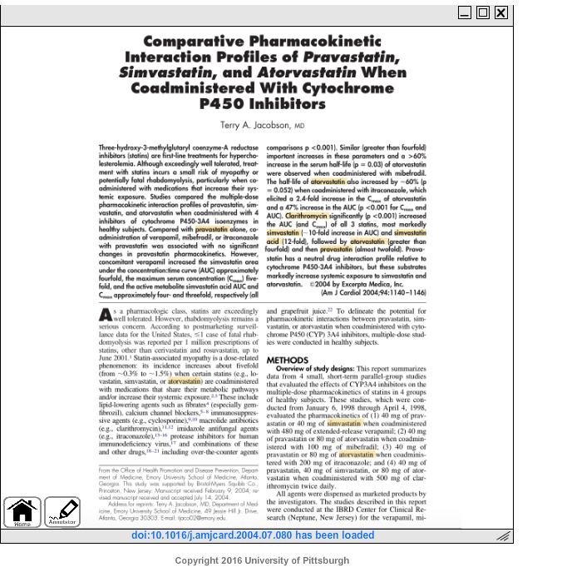

Some drug names may already be highlighted in yellow; these have been *pre-annotated* by a computer tool.

(4) Select the claim.

4(a) First find the appropriate information in the input document: Input column *The sentence(s) that state the main assertion* specifies either a page location or a textual quotation. Find this text by going to the page location, reading through the document, or by hitting Ctrl-F and searching for the sentence.

4(b) Highlight *the sentence(s) that state the main assertion*, then click the “MP” button.

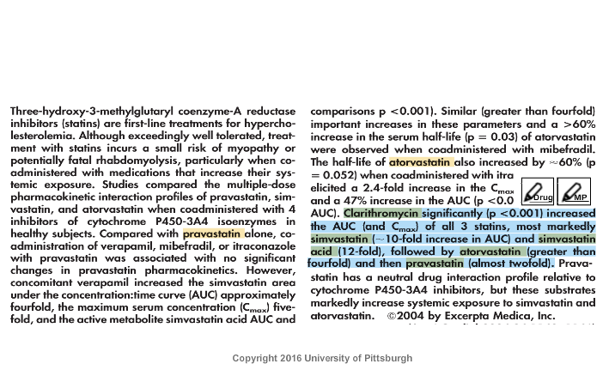

4(c) Next click “create a claim”

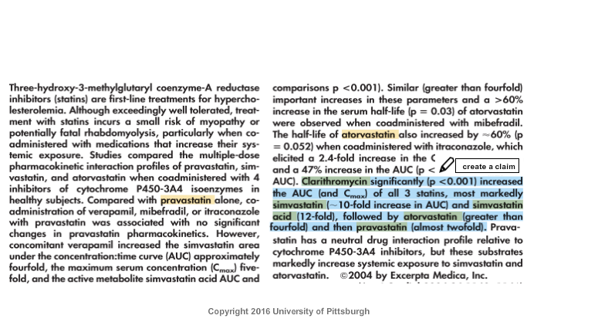

(5) Next we need to enter the text associated with this claim into the annotation interface.

5(a) First gather the required information from the input document, as follows:

- Drug 1. See Column “*Drug*”

- The property, or relationship. See Column “*Property*”

- Drug 2 or inhibitor. See Column “*Value (drop down - for non-quantitative assertions)*”

- The method. Currently, there is only one method – Clinical Trial.

5(b) Second, select the drug name (from input column *Drug*), relationship (from input column *Property*), and method (Clinical Trial). Note that “save” is greyed out because more information is needed

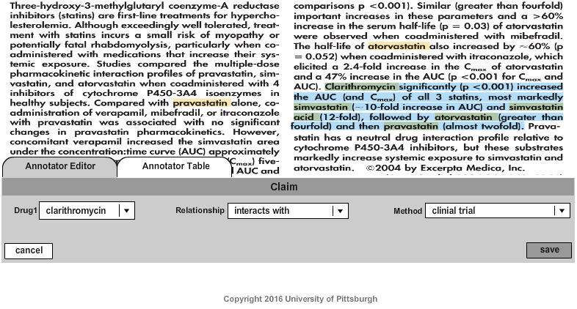

5(c) The Drug2 box appears; enter the second drug (from input column “*Value (drop down - for non-quantitative assertions)*”)*)*. 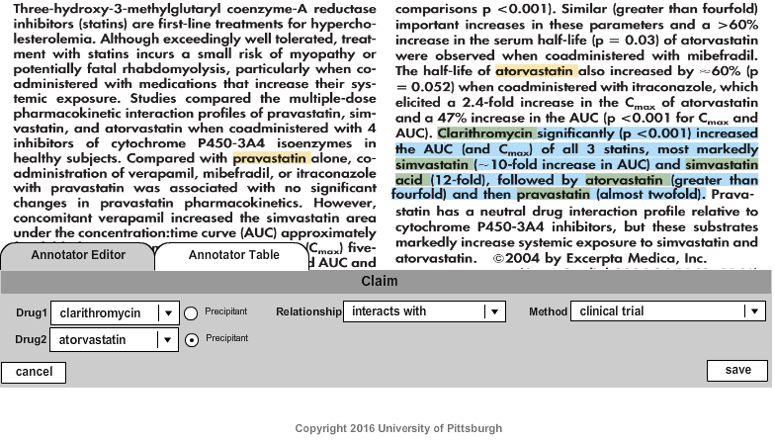

5(d) Indicate which drug is the precipitant by clicking the radio button labeled “Precipitant”.

5(e) Click “Save”.

5(f) A popup appears asking what you would like to do, for this text span.

* + add another claim
  + add material/data for an existing claim
  + finish with this span, move on

Select one of these options and click “OK”.

In this case we want to add another claim for the same text span.

This would be indicated when the SAME filename listed in input *Column: Article* has multiple rows, where those rows have the SAME text/location specified in input *Column: The sentence(s) that state the main assertion*.

Therefore, we click “add another claim”

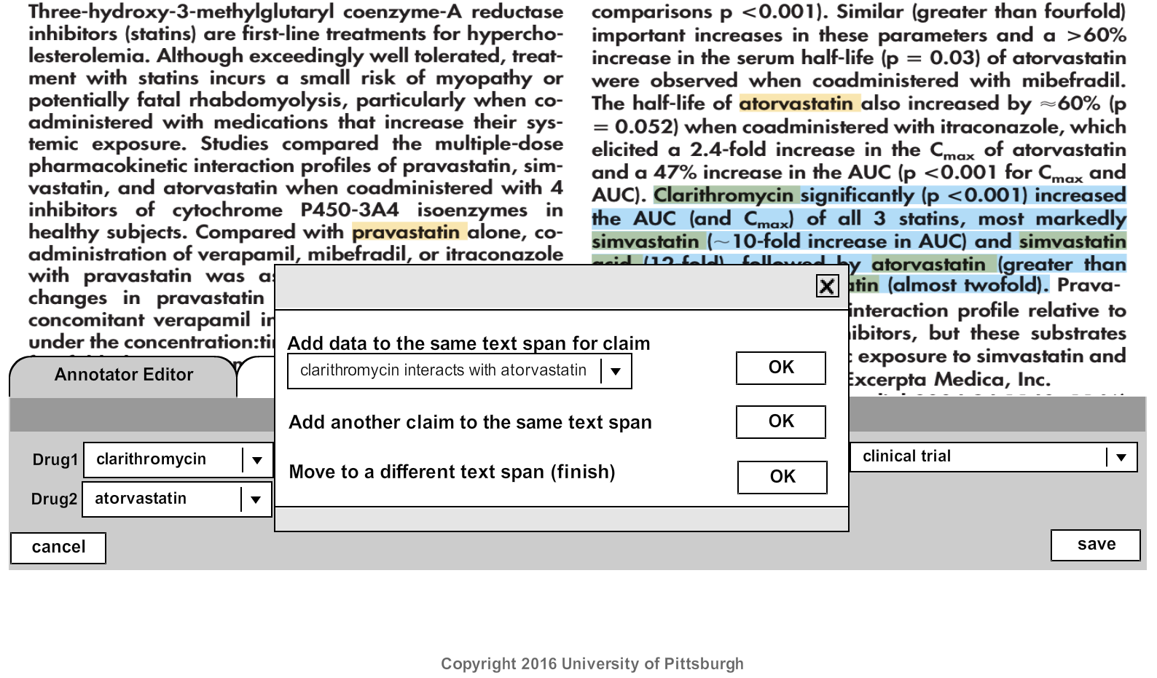

(6) We repeat step 4 in order to add the second claim.

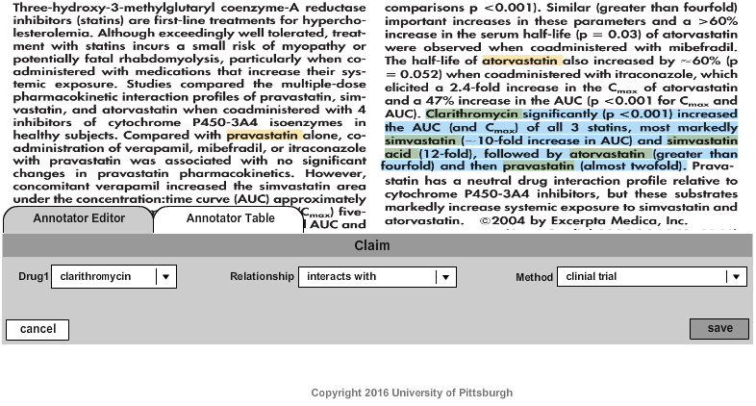

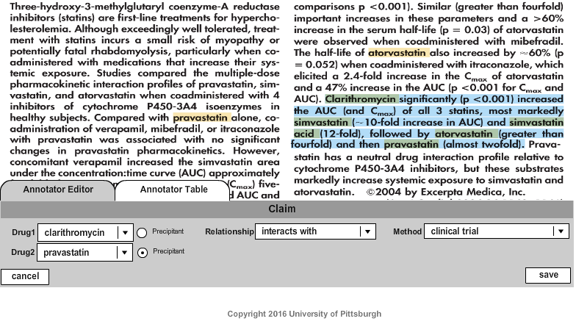

In this case we STILL want to add another claim for the same text span.

This would be indicated when the SAME filename listed in input *Column: Article* has multiple rows, where those rows have the SAME text/location specified in input *Column: The sentence(s) that state the main assertion*.

Therefore, we AGAIN click “add another claim”

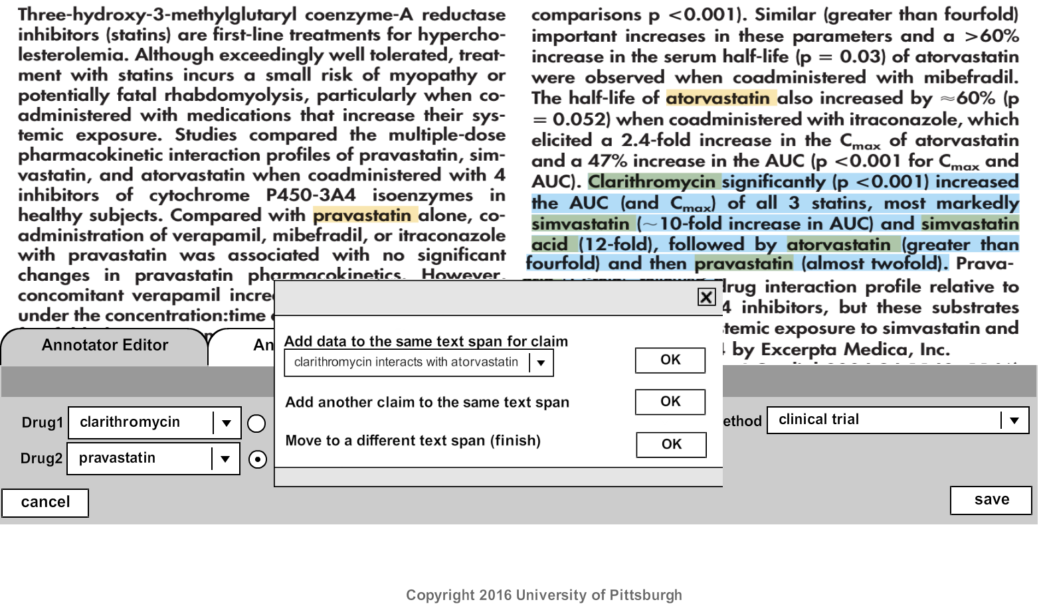

(7) We again repeat step 4 for the third claim. There is a small difference because simvastatin is a substrate; we know this because *Column Property* of the input is “substrate_of”.

7(a) We enter Drug 1 (from input *Column Drug*) and Relationship (from input *Column Property*).

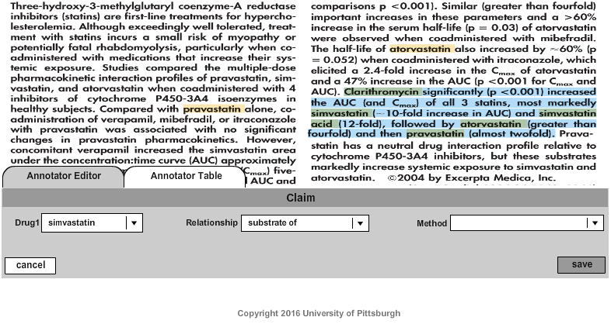

7(b) Next we add Method, which is Clinical Trial.

7(c) Once we choose “substrate of” for the relationship, and “clinical trial” for the Method, we are prompted for the Enzyme as well as for Drug 2.

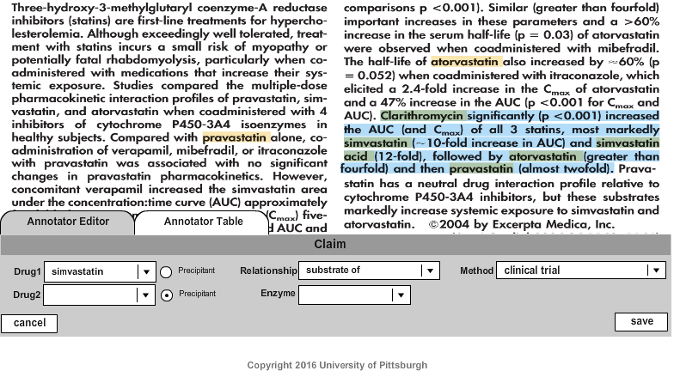

7(d) Enter Enzyme (from Column “*Value (drop down - for non-quantitative assertions)*”) and Drug2. 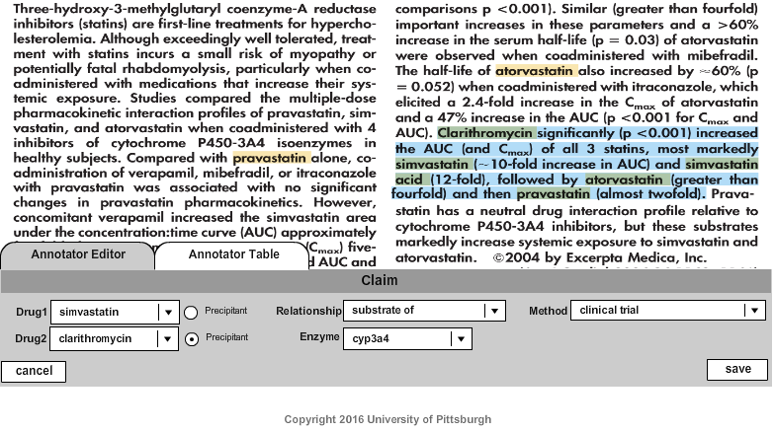

7(e) In this case we STILL want to add another claim for the same text span.

This would be indicated when the SAME filename listed in input *Column: Article* has multiple rows, where those rows have the SAME text/location specified in input *Column: The sentence(s) that state the main assertion*.

Therefore, we AGAIN click “add another claim”

(8) Finally, follow the same procedure as in 6(a) to 6(d), as simvastatin-acid again has the “substrate of” relationship.

8(a) We enter Drug 1 (from input *Column Drug*) and Relationship (from input *Column Property*).

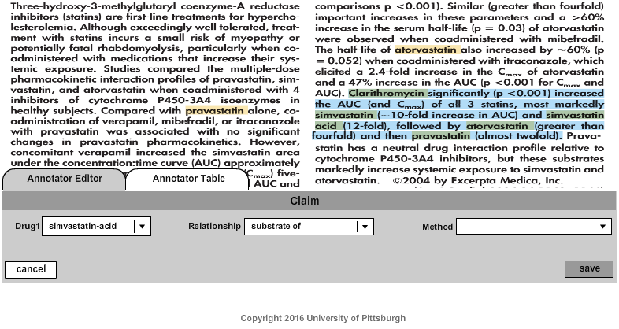

8(b) Next we add Method (Clinical Trial).

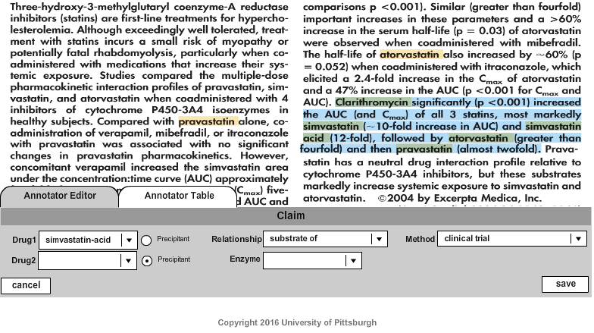

8(c) Once we choose “substrate of” for the relationship, and “clinical trial” for the Method, we are prompted for the Enzyme as well as for Drug 2.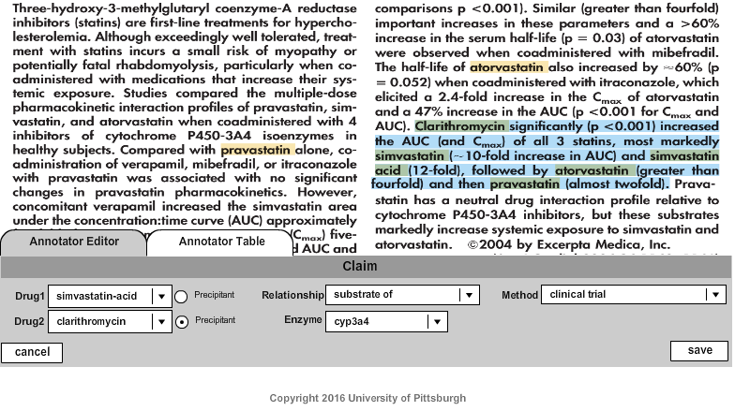

8(e) Once all claims are entered, click “finish with this span, move on”

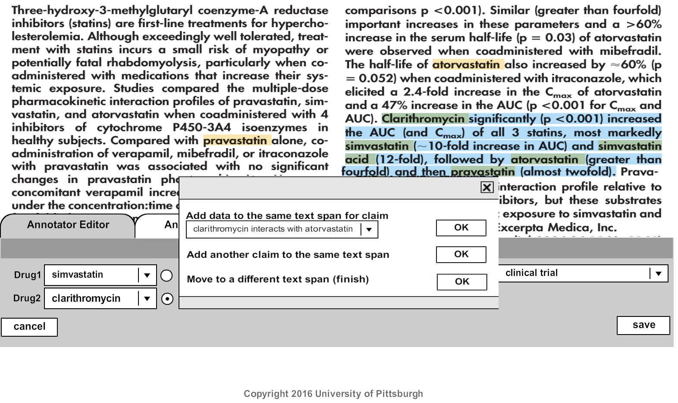

(9) This takes you to the “Annotator Table”. This specifies the information that is desired. You will annotate a span of the document and add text, for whatever information is available in the document.

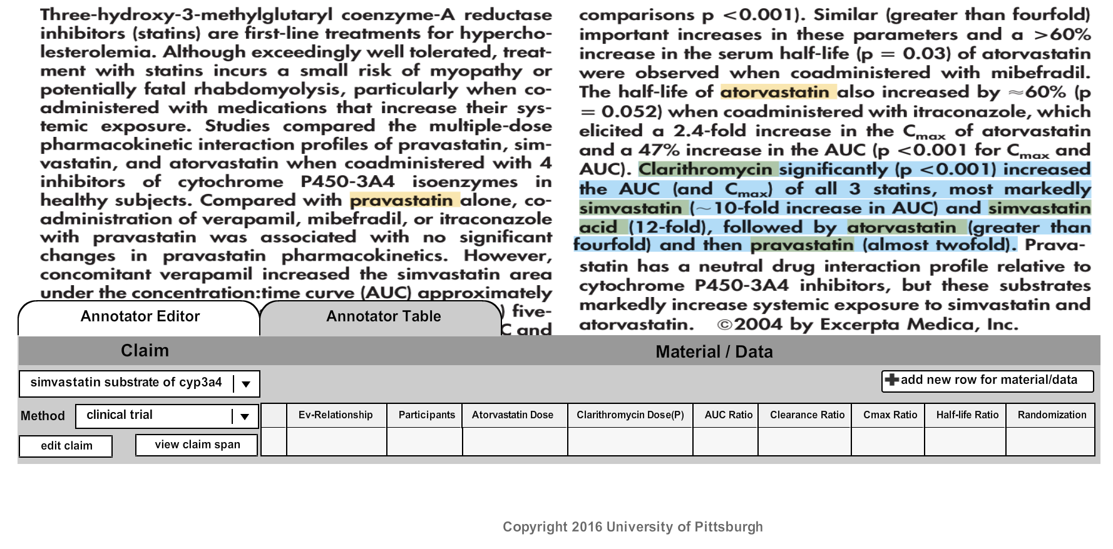

**Note that the claim shown is the last claim entered. But you can work on the claims in any order.**

***Note: if you click on a data cell without having a text span highlighted, you will get the message “please select a span before you add any materials/data”.***

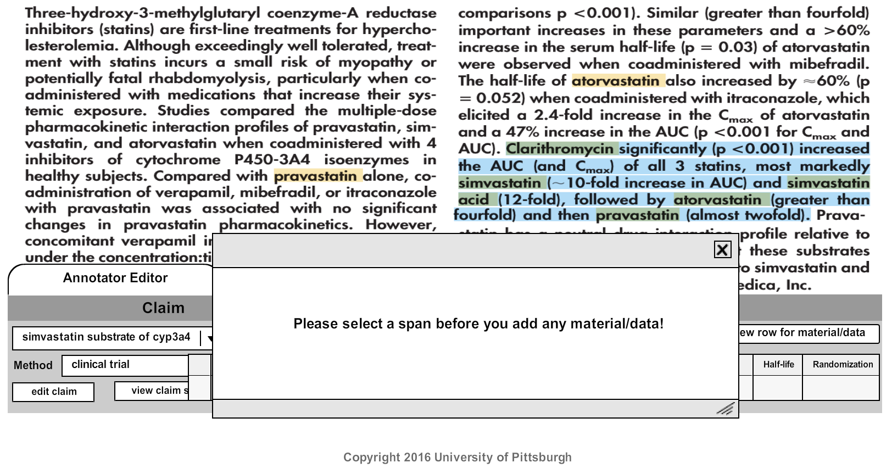

(10) Now we are ready to add the information associated with one claim, in the “material/data” part of the table.

10(a) First, determine which claim (row of the input document) you will work on.

10(b) Next, gather the required information from the input document, as follows:

* 1. Dosage/administration information for drugs specified in the claim above. Typically, Skim near the methods [*Column:* *The sentence(s), table(s), and/or figure(s) that specify the methods]*
  2. Relationship – *Column: Property*
  3. Method type – *Clinical Trial*
  4. Drug2/inhibitor – *Column:**Value (drop down - for non-quantitative assertions*
  5. Participants – *Column:* *The sentence(s), table(s), and/or figure(s) that specify the methods* and *Column: The sentence(s), table(s), and/or figure(s) that specify the results*
  6. AUC Ratio, Cmax Ratio, Clearance Ratio, and/or Half-life (T1/2) Ratio – *Column: The sentence(s), table(s), and/or figure(s) that specify the results*
  7. Ev_relationship (evidence relationship) – *Column: This is evidence. If it’s an “against”, then selects “refuse”, otherwise selects “support”.*

10(c) Select the text span associated with a data item and click the MP button. Here we select the text associated with the object drug dosage and administration. Read through, select clinical trial for methods.

10(d) Roll over “add material/data for”, and choose the claim you would like to add data for.

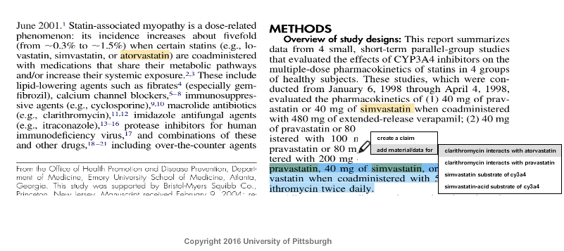

10(f) The annotator table appears, and the highlighted text has been selected. The highlighted text will get associated with the data cell you click, for the claim and method shown on the left.

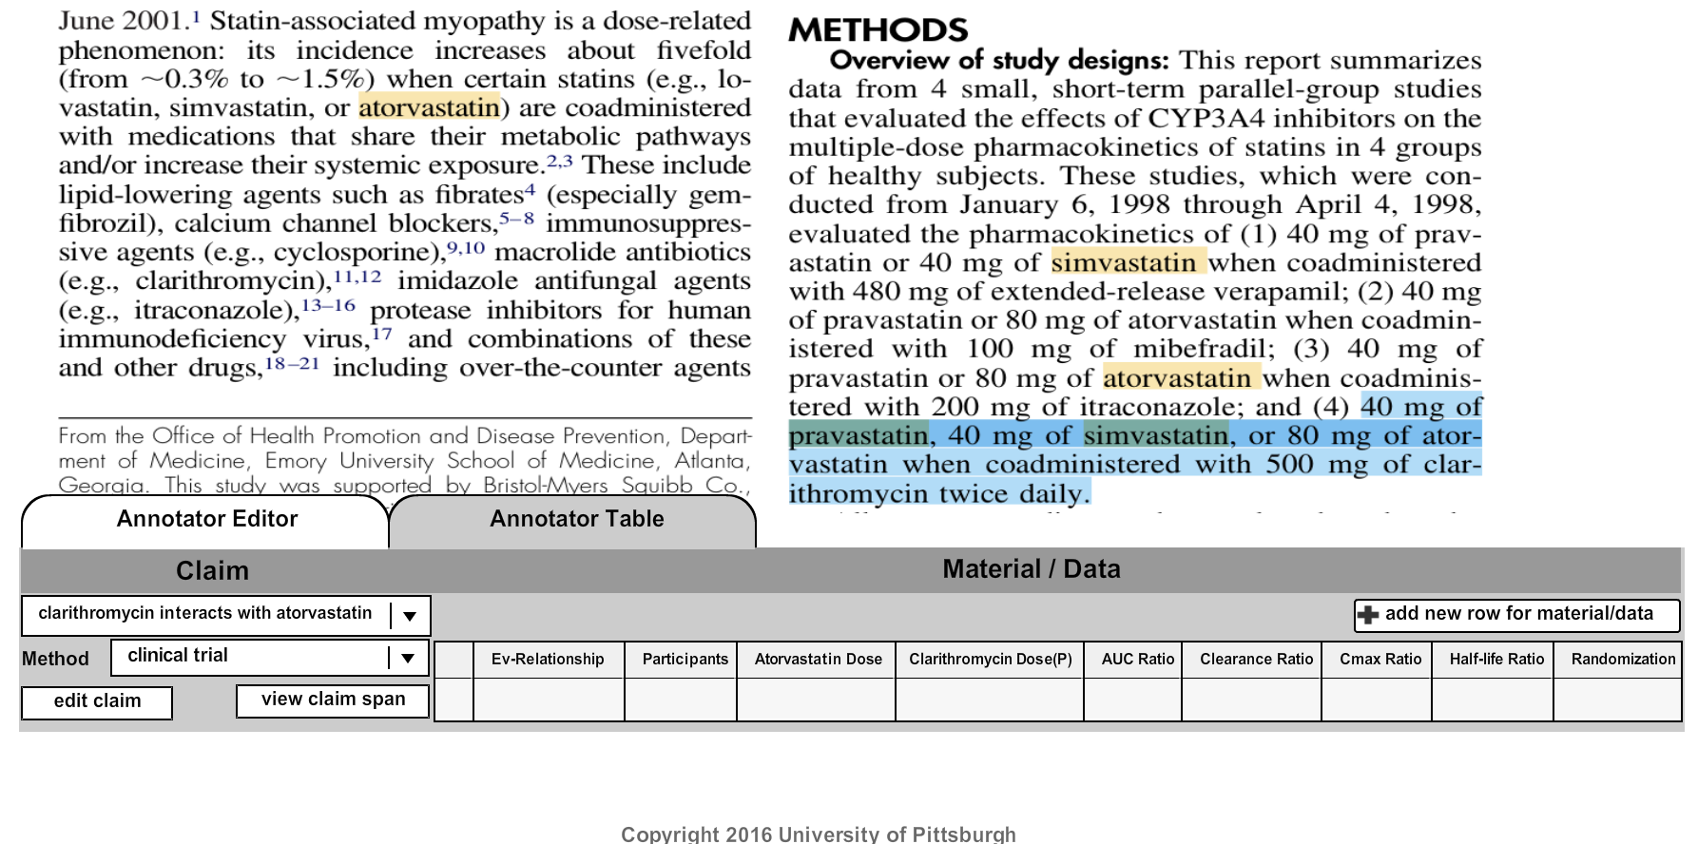

10(g) Now click on any cell in the data table associated the highlighted text. In this case we first click on the cell labeled “Atovastatin Dose”.

10(h) Enter the dose as text (in mg). Choose the formulation from the drop down. In this case the duration (days) is not specified in the text, so we leave it blank. Choose the regimen from the drop down.

***Note: For each material/data form, all the fields have to be filled out! Otherwise, the data won’t be saved****.*

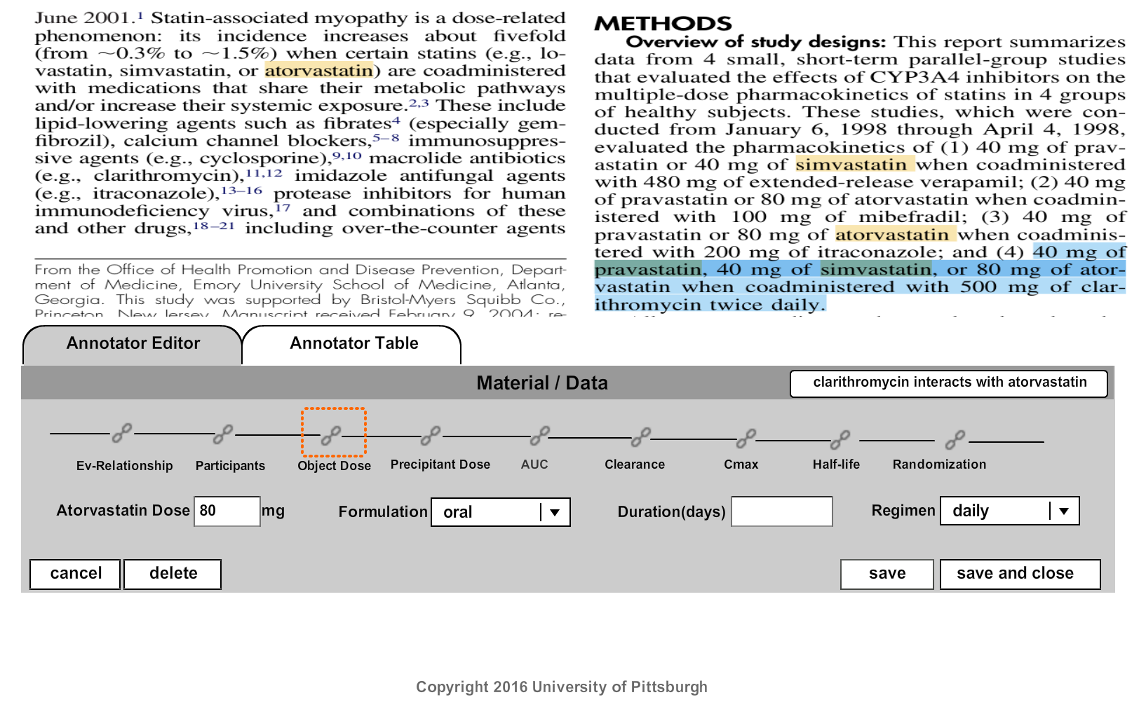

**NOTE:** Formulation

*If the highlighted text does not specifically indicate that it’s an oral dose (such as tablet, pill, etc), assume that the authors mean oral and select oral. If the authors specifically refer to an IV or the dose as mg/mL over time, then select IV.*

10(i) Click “save”. This allows you to add additional information associated with the same highlighted text span and the same claim.10(a) In this case, the highlighted text span is also associated with the precipitant dose, so we next click “precipitant dose”.

10(j) Fill in the precipitant dose (the top right corner shows the drugs, in case we need to know which drug the precipitant is). Choose the formulation from the drop down. Choose the regimen from the drop down. In this case the duration (days) is not specified in the text, so we leave it blank.

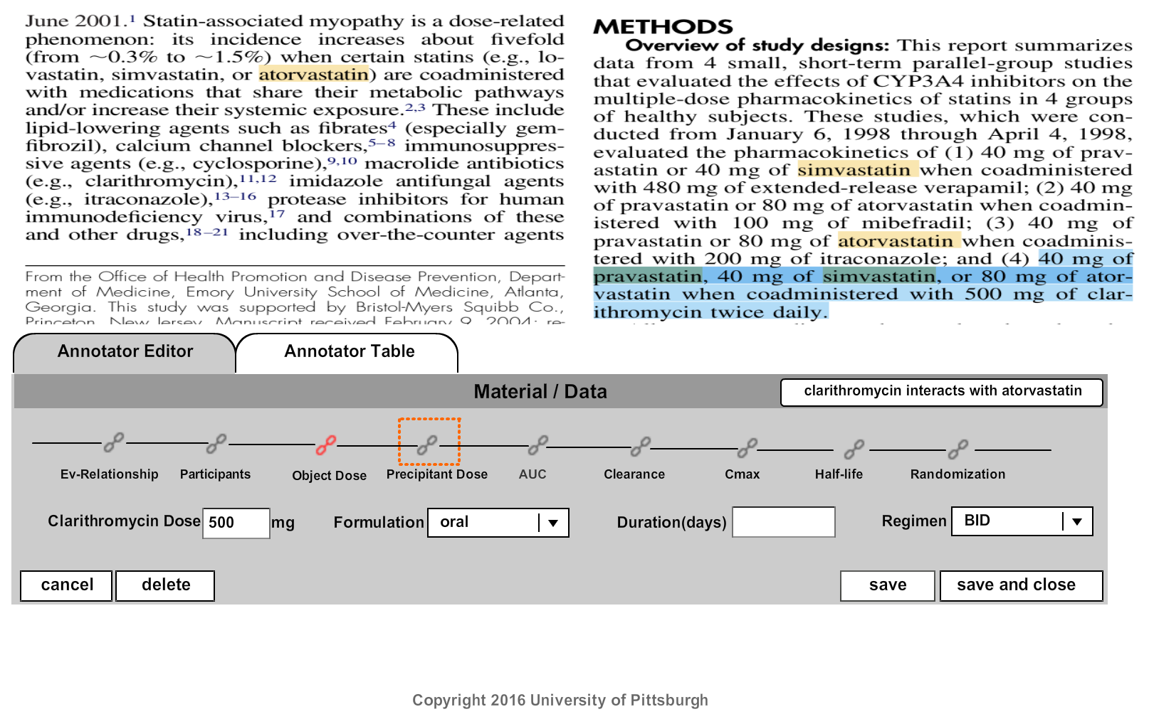

**NOTE:** Formulation

*If the highlighted text does not specifically indicate that it’s an oral dose (such as tablet, pill, etc), assume that the authors mean oral and select oral. If the authors specifically refer to an IV or the dose as mg/mL over time, then select IV.*

10(k) Click “save and close”.

10(l) You then get back to table view.

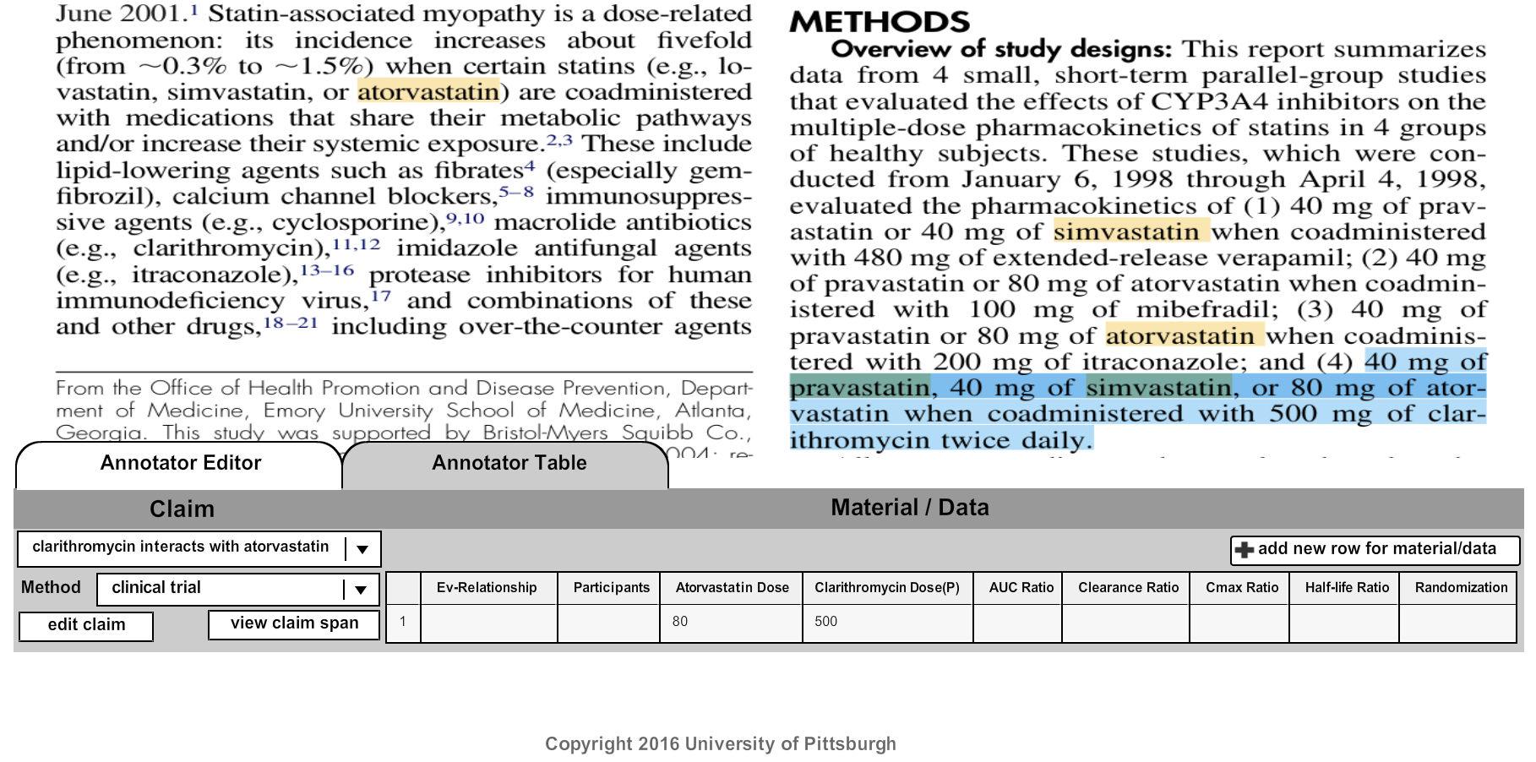

11(a) Next we select the text associated with the participants.

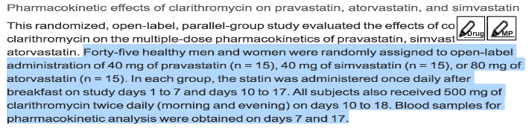

11(b) Click MP.11 (c) Roll over “add material/data for”, and choose the claim you would like to add data for.

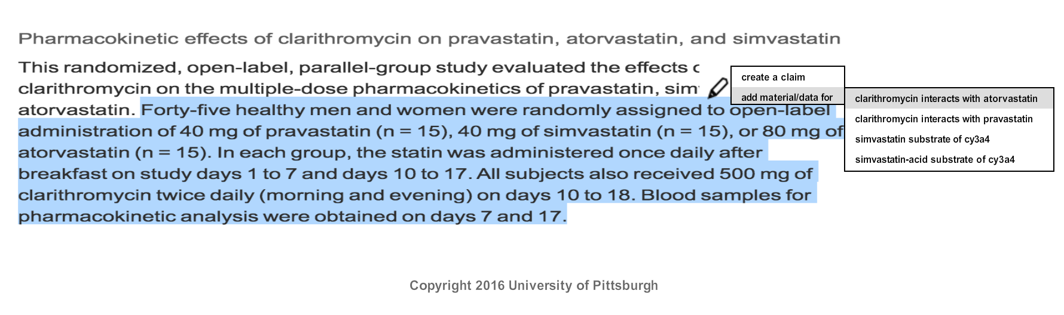

11(d) Click the participants cell in table view.

11(e) Fill in the number of study participants.

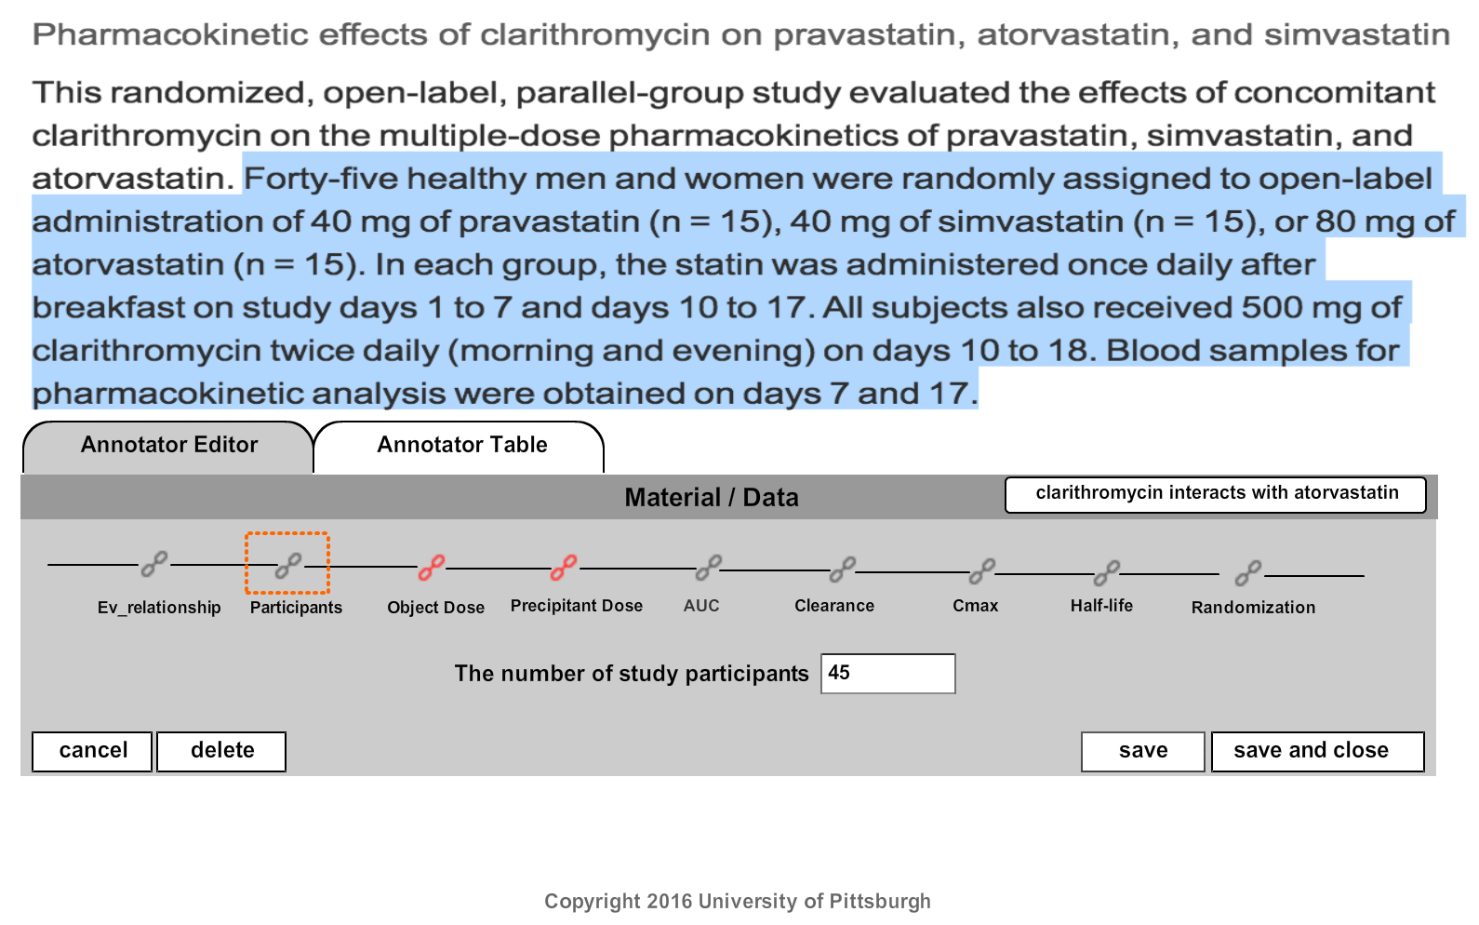

11(f) Click “save and close” to be taken back to the annotator table.

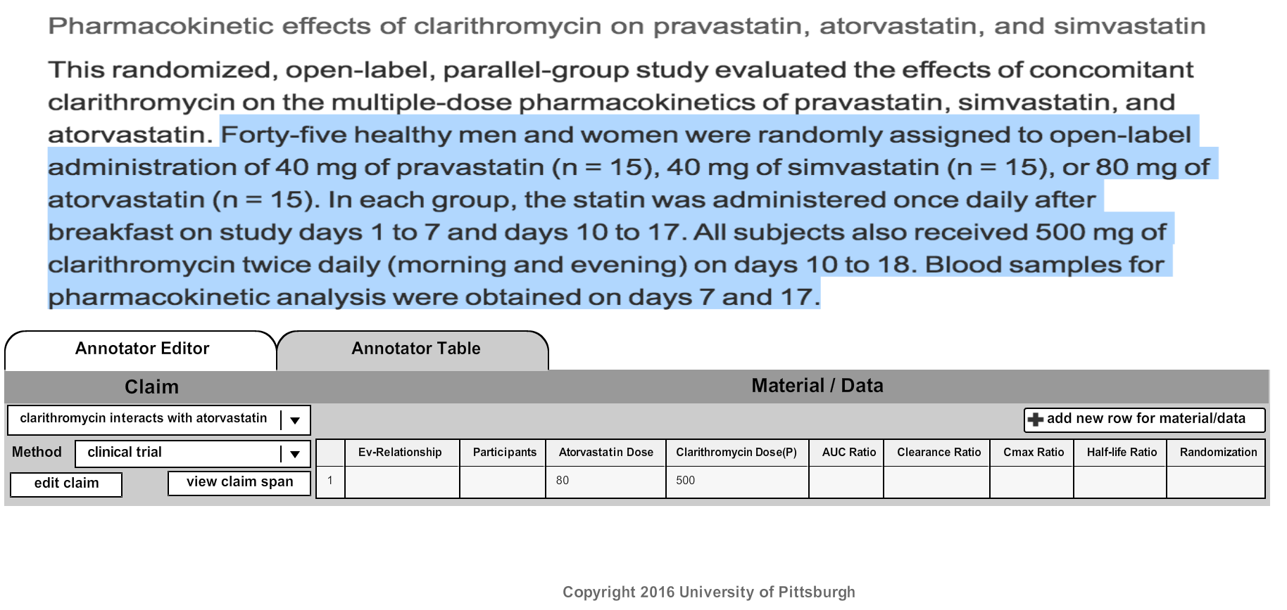

(12) Next we will work on the AUC Ratio.

**NOTE: AUC**

AUC is a measurement of the total drug exposure over time. ***The focus is on the altered AUC values***. An increase in AUC means an increase in drug exposure; a decrease means a decrease in drug exposure. If the statement includes information about the AUC (which will always refer to the object drug), in the AUC Ratio fields, type the AUC Ratio value in the AUC Ratio: text box, the AUC Ratio type (percent, fold, unk), and direction (increase, decrease, unk). If the AUC Ratio is not mentioned at all, select or type unk in all fields. Sometimes, statements will refer only to exposure, not AUC Ratio directly. In those cases, assume they mean AUC Ratio, and annotate accordingly.

***Examples of AUC information include:***

* “Cyclosporine AUC and Cmax were determined before and after the administration of fluconazole 200 mg daily for 14 days in eight renal transplant patients who had been on cyclosporine therapy for at least 6 months and on a stable cyclosporine dose for at least 6 weeks.”
* “Concomitant treatment with rabeprazole (20 mg daily) and ketoconazole in healthy subjects decreased the bioavailability of ketoconazole by 30% and increased the AUC and Cmax for digoxin by 19% and 29%, respectively. Therefore, patients may need to be monitored when such drugs are taken concomitantly with rabeprazole. Co-administration of rabeprazole and antacids produced no clinically relevant changes in plasma rabeprazole concentrations.”

12(a) Highlight the “AUC Ratio” information.

12(b) Click MP

12(c) Roll over “add material/data for”, and choose the claim you would like to add data for.

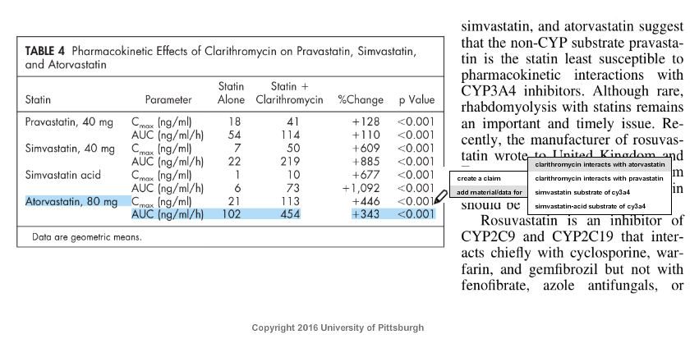

12(d) Click the “AUC Ratio” cell in the table.

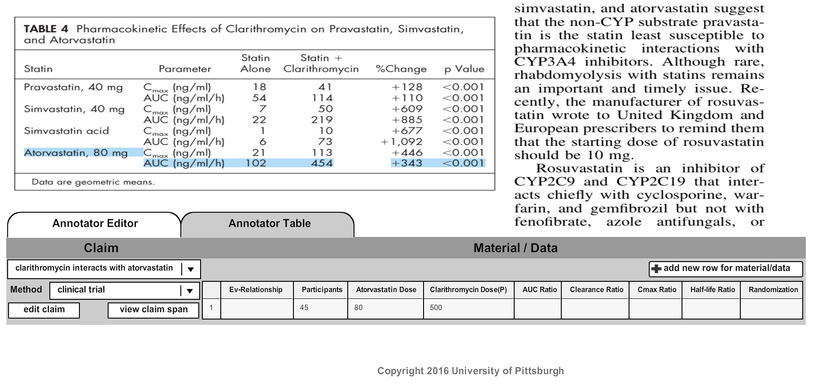

12(e) Here we type in the numerical portion of the “% Change” (343) into “AUC Ratio”, select the radio button “percent” and the AUC Ratio direction “increase”.

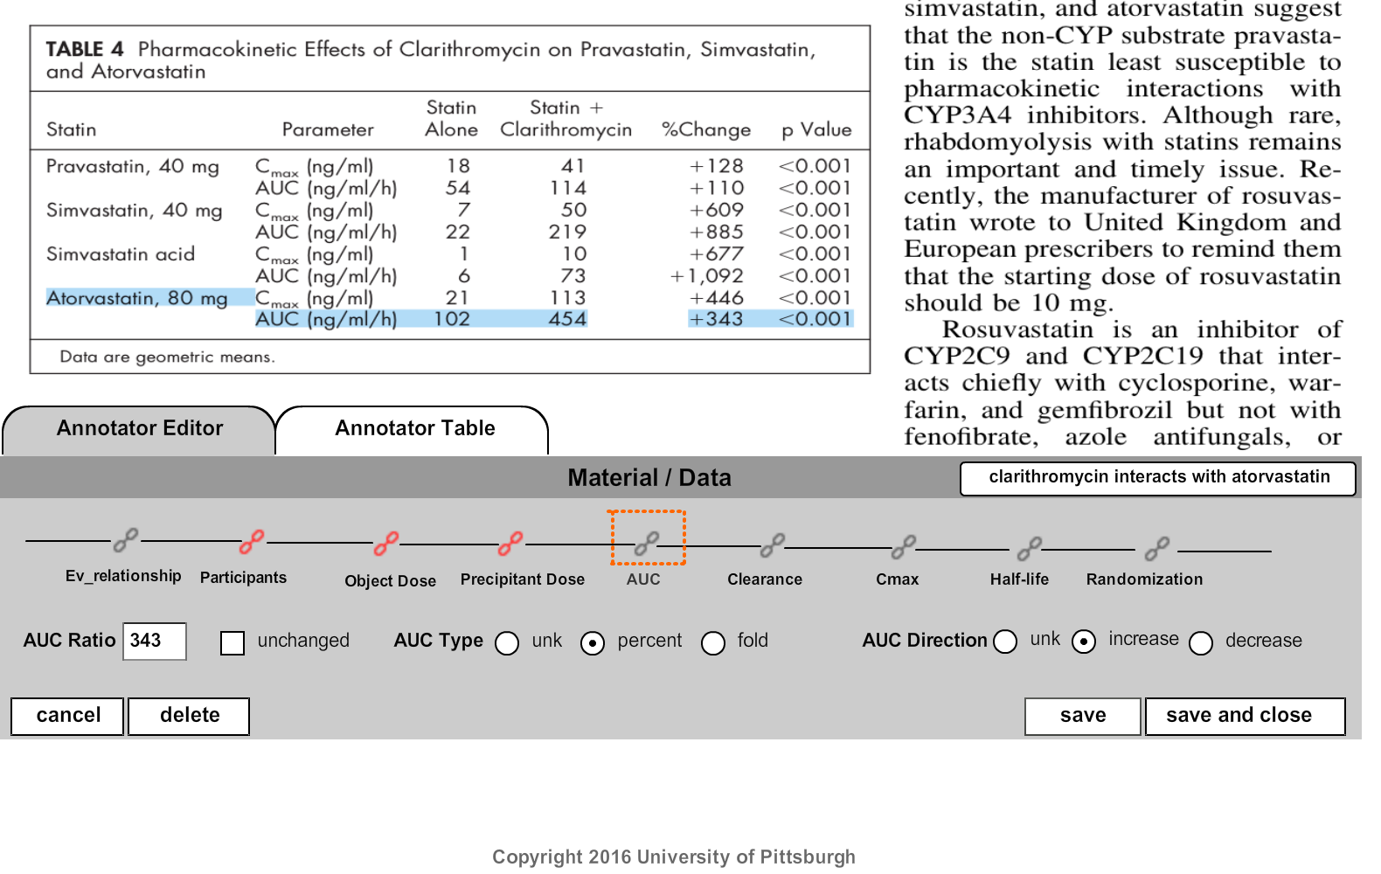

12(f) When we click “save and close” the AUC Ratio appears in the table.

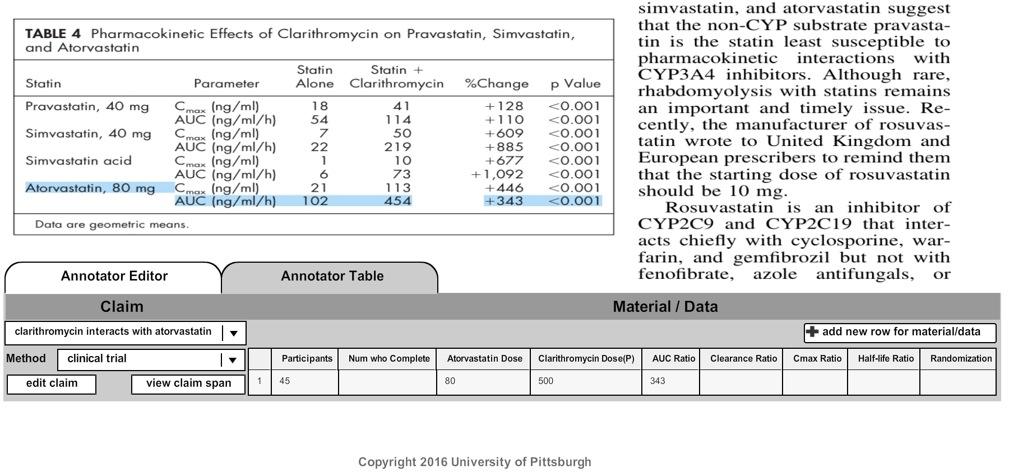

(13) Next we work on the Cmax Ratio.

**NOTE: Cmax** is a measurement of the highest serum concentration of the drug in the blood after administration of one dose. ***The focus is on the altered Cmax values***. If the statement includes information about Cmax Ratio (which will always refer to the object drug), in the Cmax Ratio fields capture the Cmax Ratio value, the Cmax Ratio type (percent, fold, unk), and Cmax Ratio direction (increase, decrease, unk) or else type/select unk in all fields accordingly.

***Examples of Cmax information include:***

* “Concomitant treatment with rabeprazole (20 mg daily) and ketoconazole in healthy subjects decreased the bioavailability of ketoconazole by 30% and increased the AUC and Cmax for digoxin by 19% and 29%, respectively. Therefore, patients may need to be monitored when such drugs are taken concomitantly with rabeprazole. Co-administration of rabeprazole and antacids produced no clinically relevant changes in plasma rabeprazole concentrations.”
* “There was an increase in mean repaglinide Cmax and AUC (1.7- and 2.4-fold, respectively), following repeated doses of teriflunomide and a single dose of 0.25 mg repaglinide, suggesting that teriflunomide is an inhibitor of CYP2C8 in vivo. The magnitude of interaction could be higher at the recommended repaglinide dose [see DRUG INTERACTIONS (7)].”

13(a) Next highlight the “Cmax Ratio” information.

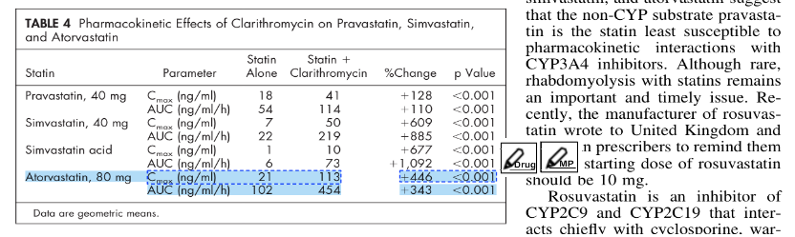

13(b) Click MP

13(c) Roll over “add material/data for”, and choose the claim you would like to add data for.

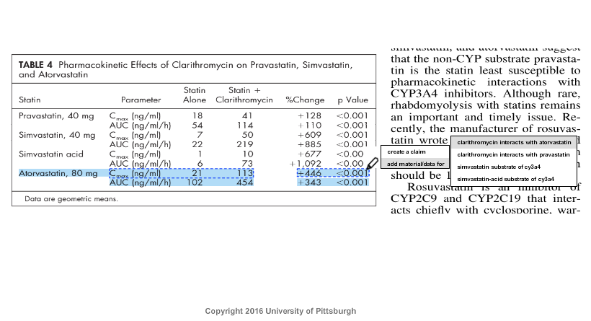

13(d) The table appears, select “Cmax Ratio”.

13(e) Here we use the “%Change” to specify the “Cmax Ratio”, select the radio button “percent” and the Cmax Ratio direction “increase”.

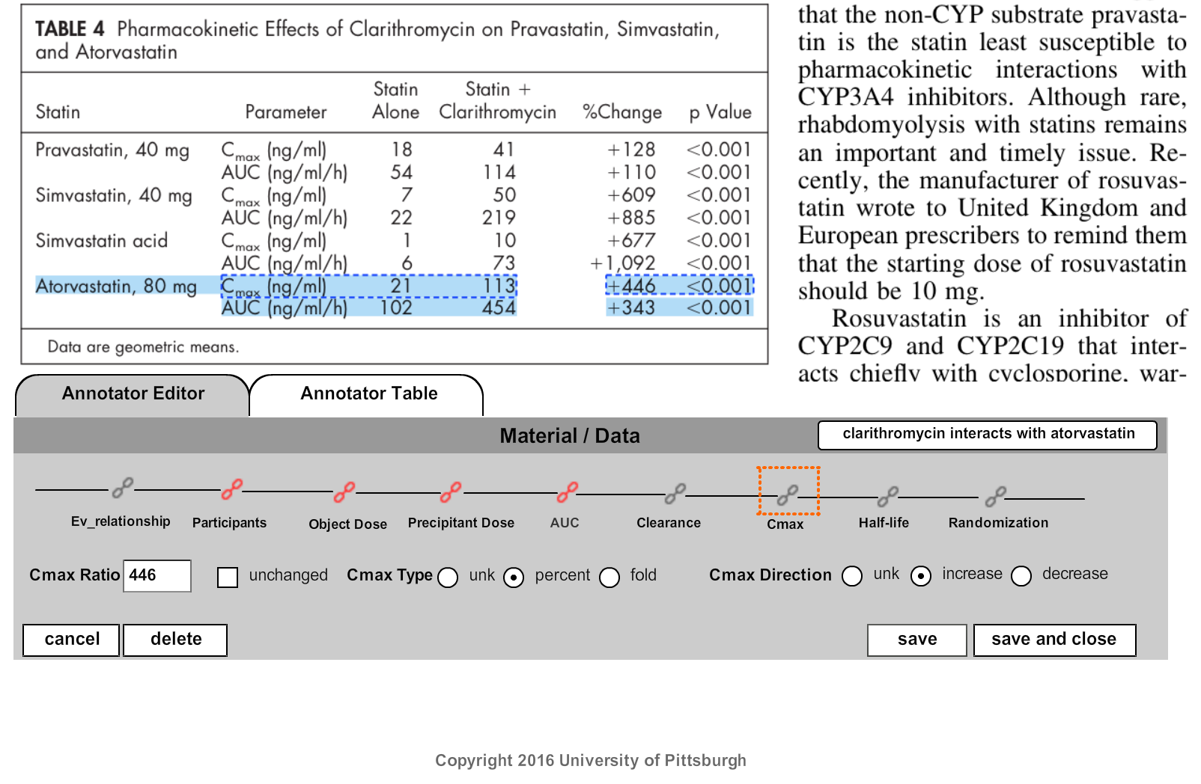

13(f) Click “save and close” to be taken back to the annotator table.

(14) Verify that all the information that was available appears in the table.

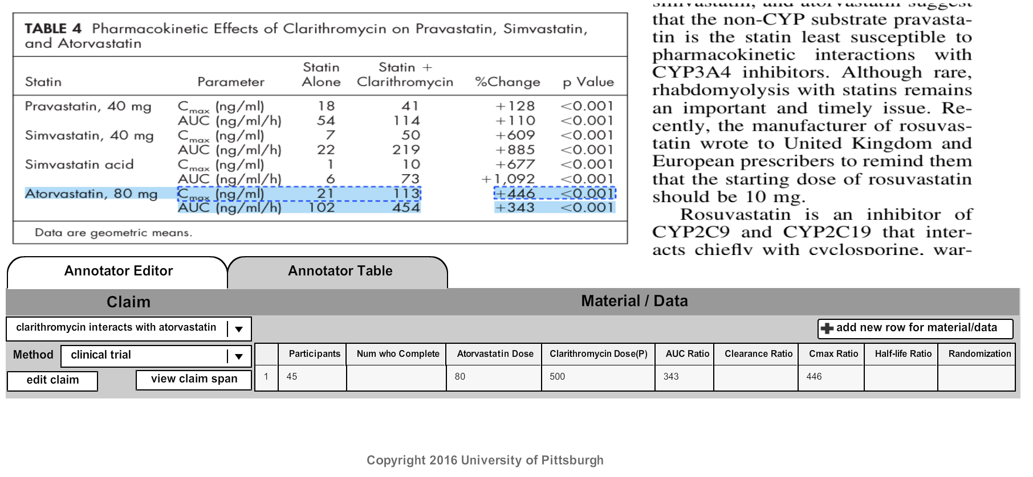

(15) Repeat the same process (from steps 13 to 14) for Clearance ratio, half-life ratio and randomization data/material fields for the same claim.

(16) Repeat the same process (from steps 8 to 14) for each of the remaining claims associated with this paper. Each claim is associated with a row of the input file.

(17) If you do as above, the annotations will be saved in the system safely. Please remember to log off NoMachine and Pulse Secure every time you finish the work.

Version History

|  |  |  |  |
| --- | --- | --- | --- |
| **S.No** | **Date** | **Version** | **Changes Description** |
| 1 | 10-Feb-16 | V1 | Creation |
| 2 | 26-May-16 | V2 | Add authors, fix spelling of Pittsburgh, add mockups of new annotation interface. Finalized screenshots for v2. |
| 3 | 21-July-16 | V3 | Add evidence relationship. Finalized the material/data form. |
| 4 | 09-August-16 | V4 | Add Vlan Information, URL. Add Ratio and remove PK. |